Wednesday, September 11, 2013

Moderating: Brenda Morris, Junior Board Member, Division of Food Safety
Florida Department of Agriculture

8:00-9:00 | Manufactured Foods Regulatory Standards Update-Guy F. Delius, FDA Office of Partnerships
9:00-9:45 | Food Allergy Research and Education-Mike Spigler, FARE –Vice President of Education
9:45-10:00 | Break
10:00-11:15 | Round Table Discussion of State Program Directors – Triumphs and Heartbreaks
11:15 | Presidents Closing Remarks-Mark Reed
 | Conference Adjourn

Special Thank You To:

Buddy Woodson, Auctioneer extraordinaire and
assistant Tyler Thornburg

Doug Saunders of Coca Cola CO – North America

Jim Kohl of McKee Baking Company

Jesse Lewis of K-VA-T Food Stores

Mary Logan for being our Ms AFDOSS

All the many contributors to our Scholarship Fund

"Funding for this conference was made possible, in part, by the Food and Drug Administration through grant 1R13FD004160-03. The views expressed in written conference materials or publications and by speakers and moderators do not necessarily reflect the official policies of the Department of Health and Human Services; nor does any mention of trade names, commercial practices, or organization imply endorsement by the United States Government"

Association of Food and Drug

Officials of the Southern States

Fall 2013 Educational Conference

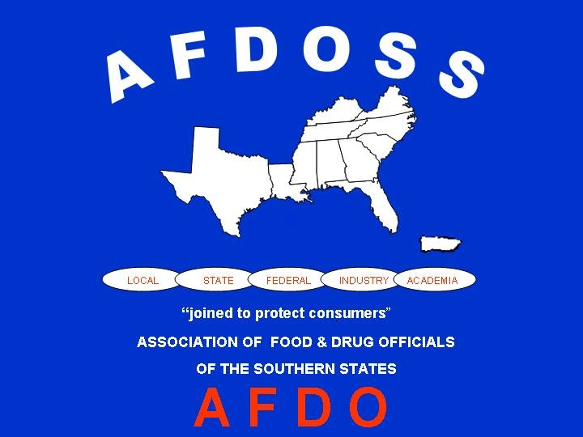

September 8-11, 2013

Park Vista Hotel
Gatlinburg, TN

Sunday, September 8, 2013
33 2:45 -3:00 | Break
33 3:00-4:30 | Brief History of Integration – Joe Corby  Integrated Food Safety Toolkit – Cameron Smoak
6 6:30-7:00 | Reception
7 7:00 | Holeman Award Banquet/Live Auction
3:00 – 5:00 Registration
4:00 – 6:00 Executive Board Meeting
6:00 – 7:00 Welcome Reception

Monday, September 9, 2013
7:00 – 8:00 Breakfast provided
7:45 – 8:15 Registration

Moderating: Rita Johnson, Florida Department of Agriculture & Consumer Service

8:00-8:10 | Call to Order-AFDOSS President, Mark Reed  Invocation-Rita Johnson
8:10-8:20 | President’s Welcome- Mark Reed
8:20-9:00 | Chamberlin Farms Cantaloupe Outbreak – Elizabeth Russell, Division of Epidemiology Kentucky Department of Health
9:00-9:30 | Intentional Contamination Event Investigation – Jamie Dement, Florida Department of Health
9:30-9:45 | Break
9:45-10:15 | Ensuring Food Safety during Transportation in Florida – Brenda Morris, Environmental Administrator, Florida Department of Agriculture and Consumer Services
10:15-11:45 | Rapid Response Team State Updates – Georgia, Florida, Mississippi, North Carolina, Virginia  FDA Southwest Region, FDA Southeast Region  FDA Atlanta District, FDA Florida District, FDA New Orleans District
11:45-1:00 | Lunch (on your own)  (RAFDOSS meets after lunch)
Moderating: | Natalie Adan, AFDOSS Senior Board Member, Georgia Dept. of Agriculture
1:00-1:30 | AFDO Update – Dave Read
1:30- 2:00 | Southeast Region Lab Presentation – Khalil Kerdahi
2:00-2:45 | Auburn University Food Safety Institute – Pat Curtis, PHD, Director AUFSI

Tuesday, September 10, 2013

Moderating: Courtney Mickiewicz, Tidewater Regional Manager, Virginia Department of Agriculture and Consumer Services, Food Safety & Security

8:00-9:45 | IFPTI Fellows Presentation
9:45-10:00 | Break
10:00-10:45 | Seafood Safety at Retail– Jeff Hawley, Harris Teeter SuperMarkets, Inc.
10:45-11:30 | National Conference of State Legislatures- Doug Farquhar
11:30-1:00 | Business Luncheon (lunch provided)
Moderating: | Jeff Hawley, Harris Teeter, Food Safety Mgr.
1:00-1:45 | Improving Food Supply Transportation -Terry Levee, Deloitte and Touche
1:45-2:20 | Quality control programs in the nut/snack industry – Angelo Losurdo, Vice President of Quality Assurance, Ann’s House of Nuts
2:20-2:35 | Committee Updates-Natalie Adan, AFDOSS Senior Board Member
2:35-5:00 | AFDOSS Committee Meetings-Committee Chairs

