Wednesday, September 16, 2015

Moderating: Shanna Lively, Tennessee Department of Agriculture

8:00-8:30 | IFSS Training Update – Jerry Wojtala, IFPTI
8:30 – 9:45 | How the MFRPS Have Impacted State Manufactured Food Inspection Programs / MFRPA Update - Pam Miles VA, Matt Colson FL, Natalie Adan GA , Anita McMullen, NC
9:45 – 10:15 | MFRPS National Status and Future – Guy Delius FDA Office of Partnership
10:15-10:30 | Break
10:30 | Presidents Closing Remarks – Natalie Adan
 | Conference Adjourn

Special Thank You To:

Buddy Woodson, Auctioneer extraordinaire and
assistant Tyler Thornburg

Doug Saunders of Coca Cola CO – North America

Jim Kohl of McKee Baking Company

Jesse Lewis of K-VA-T Food Stores

Mary Logan for being our Ms AFDOSS

All the many contributors to our Scholarship Fund

"Funding for this conference was made possible, in part, by the Food and Drug Administration through grant 5R13FD004160-05. The views expressed in written conference materials or publications and by speakers and moderators do not necessarily reflect the official policies of the Department of Health and Human Services; nor does any mention of trade names, commercial practices, or organization imply endorsement by the United States Government"

Association of Food and Drug

Officials of the Southern States

Fall 2015 Educational Conference

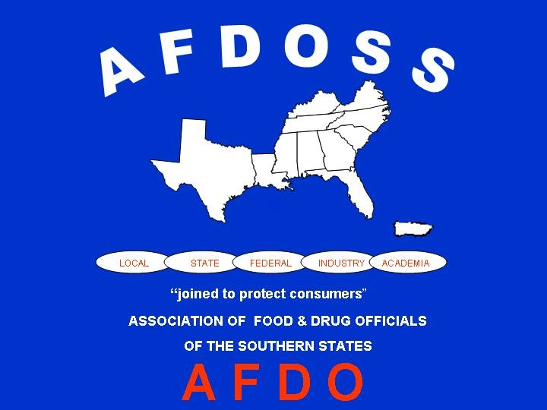

September 13 - 16, 2015

Gatlinburg, TN

Sunday, September 13, 2015
3:00 – 5:00pm Registration
4:00 – 5:30pm Executive Board Meeting
6:00 – 7:00 pm Welcome Reception

Monday, September 14, 2015
7:00 – 8:00 Breakfast provided in Restaurant
7:45 – 8:15 Registration

Moderating: Rick Caldwell, South Carolina Dept of Health
And Environmental Control

8:00-8:15 | Call to Order-AFDOSS President, Natalie Adan  Invocation-Rita Johnson
8:15-8:45 | AFDO Update – Stan Stromberg, AFDO President
8:45-9:15 | The Gulf Oil Spill – 5 Years Later – Kevin Armbrust, Chair of Department of Environmental Sciences, LSU
9:15-10:00 | E. Coli at Jack in the Box – Darin Detwiler, Senior Policy Coordinator, STOP Foodborne Illness
10:00-10:15 | Break
10:15-11:15 | Fermented Foods – Joell Eifert, Virginia Tech
11:15 – 12:00 | USDA/FSIS update Keith Payne, Deputy Director FSIS/ USDA
12:00-1:00 | Lunch on your own  (RAFDOSS meets for lunch)
Moderating: | Donna Wanucha, Regional Retail Food Specialist FDA/Southeast
1:00 – 1:45 | Retail Program Success – Andre Pierce, Environmental Health and Safety Director Wake County NC
1:45 – 2:30 | Active Shooter in your Establishment –  Michael Freeman, FBI
2:30 – 2:45 | Break
2:45 – 3:45 | Retail Panel Discussion: Food Waste Reduction and How Food Safety Plays a Role Shana Davis, Kroger; Tim Mitchell, Publix; Rick Barney, Winn Dixie
3:45 – 5:00 | IFPTI Update – Jerry Wojtola, IFPTI  IFPTI Presentations - Matt Colson, FL; Jessica Badour, GA; Tessa Dixon, LA, Eugene Evans, NY; Brian Buchwald, OK
6:00 – 6:30 | Reception
6:30 | Banquet and Live Auction

Tuesday, September 15, 2015

Moderating: Queen Swayze, Mississippi Department of Health

8:00-9:00 | Avian Influenza: Kirsten Knopff, MBA, Minnesota Dept of Agriculture, Joanna Davis, DVM USDA APHIS
9:00 – 10:00 | Preventive Control Rule Final – Anita McMullen, NC
10:00-10:15 | Break
10:15-11:00 | NC Baptist Men - Feeding the Masses - Gaylon Moss, Disaster Relief Director NC Baptist Men/Baptists on Mission
11:00-11:45 | Implementing the South Carolina Special Processes Program – Jon Wheeler, Environmental Health Manager, DHEC, South Carolina
11:45-1:00 | Business Luncheon (Lunch provided)
Moderating: | Shana Davis, Kroger
1:00-1:45 | E. coli O157:H7 Outbreak Associated with Consumption of Unpasteurized Milk KY 2004 Tracy Vaughn, R.N, KDPH.; Carrell Rush, Epidemiologist, KDPH; Pablo Munoz, Director, Lincoln Trl. District HD
2:00 – 5:00 | Committee Update and Meetings: Courtney Mickiewicz, Virginia Department of Agriculture

