Wednesday, September 14, 2016

Moderating: Jamie DeMent, Florida Department of Health
8:00 – 8:30 FSIS Working with State Partners at Retail – Keith Payne, FSIS USDA
8:30 – 9:15 Preventive Control and Produce Rule Update – Anita MacMullan, North Carolina Department of Agriculture and Consumer Services
9:15 – 9:45 PFP Update – Alan Tart, Office of Partnerships, FDA
9:45 – 10:00 Break
10:00 – 10:45 CFP Update – Laurie Farmer, FDA
10:45 – 11:30 Egg Safety and Salmonella Enteriditis Control – George Zameska, National Pasteurized Eggs, Inc.
11:30 – 11:45 President’s Closing Remarks – Brenda Morris
Conference Adjourn

AFDOSS would like to extend a special Thank You to:

Buddy Woodson, Auctioneer Extraordinaire and
assistants, Tyler Thornberg & John Sanford

Virginia Mercer – McKee Baking Company

Jesse Lewis / Barbara Thomas – K-VA-T Food Stored

Mary Logan, Ms AFDOSS

Craig Nielsen, New AFDOSS Secretary/Treasurer

All of the many contributors to our Scholarship Fund

“Funding for this conference was made possible, in part, by the Food and Drug Administration through grant 4R13FD004160-05. The views expressed in written conference materials or publications and by speakers and moderators do not necessarily reflect the official policies of the Department of Health and Human Services; nor does any mention of trade names, commercial practices, or organization imply endorsement by the United States Government.”

Association of Food and Drug
Officials of the Southern States

2016 Educational Conference

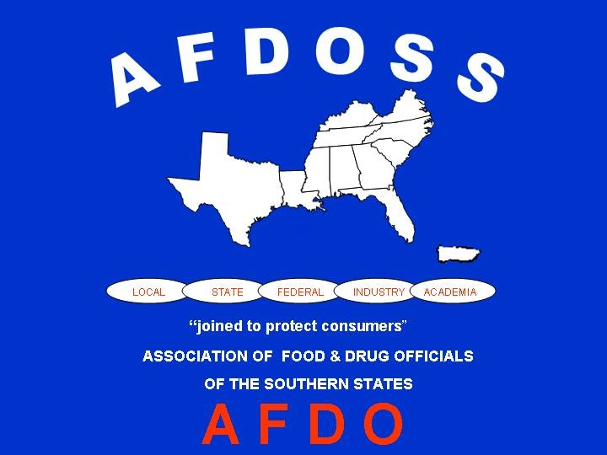

September 11-14, 2016

Park Vista Hotel
Gatlinburg, TN
Sunday, September 11, 2016

3:00 – 5:00 Registration
4:00 – 6:00 Executive Board Meeting
6:00 – 7:00 Welcome Reception

Monday, September 12, 2016

7:00 – 8:00 Breakfast provided
7:45 – 8:15 Registration
Moderating: Rick Caldwell, South Carolina Department of Health
8:00 – 8:10 Call to Order – AFDOSS President, Natalie Adan
Invocation – Rita Johnson
8:10 – 8:15 President’s Welcome – Natalie Adan
8:15 – 8:45 AFDO Updates – AFDO President, Steve Mandernach, Iowa Department of Inspections and Appeals
8:45 – 10:15 Cannabis Extractions, Concentrates, and Infused Products – Thuy Vu, Thuy Vu Consulting
10:15 – 10:30 Break
10:30 – 11:15 Mushrooms – Patrick Muse, North Carolina Department of Health and Human Services
11:15 – 11:45 MFRPA Update – Matt Colson, Florida Department of Agriculture and Consumer Services
11:45 – 1:15 Lunch (on your own)
Moderating: Rita Johnson, FL Dept of Ag and Consumer Services
1:15 – 2:15 Food Safety in a Digital World – Matt Schiering, VP and General Manager, Sani Professional
2:15 – 3:00 Coordinated Outbreak Response and Evaluation Network (CORE)
3:00 – 3:15 Break
3:15 – 4:15 Comparison of Preventive Control Rule to HACCP – Bill Brodegard, Schwan’s
4:15 – 5:00 Centers for Excellence – Jamie DeMent, MNS, CPM, Florida Department of Health, Food and Waterborne Disease Cord.
6:30 – 7:00 Reception
7:00 Holeman Award Banquet/Live Auction
Tuesday, September 13, 2016
Moderating: Melissa Lombardi
8:00 – 9:00 IFPTI Fellows Presentation – Priya Nair, Georgia Department of Public Health; Nikeya Thomas, Virginia Dept of Ag & Consumer Services; Jason Guzman, Texas Department of State Health Services
9:00 – 9:30 IFPTI Update – Dave Read, IFPTI
9:30 – 10:00 Office of Partnership Update – Guy Delius, FDA
10:00 – 10:15 Break
10:15 – 11:00 Industry’s Perspective for Controlling Risk Factors at
Retail – Jeff Hawley, Harris Teeter; Steve Tracey, Food Lion/Delhaize America
11:00 – 11:45 A Different Approach to Standardization – Food Survey Team SC Department of Health and Environmental Control
11:45 – 1:15 Business Luncheon
Moderating: Christopher T. Smith, CDR FDA
1:15 – 3:00 Factors that Influence Inspections – Tara Paster, Paster Training; Dionne Crawford, McDonald’s; Mark Sestak, Alabama Department of Public Health; Queen Swayze, Mississippi State Department of Health
3:00 – 3:15 Break
3:15 – 5:00 AFDOSS Committee Updates – Committee Chairs

